2019 RMJC Concours Registration  Name: _______________________________  Address: _____________________________  City: ___________ State: ___ Zip: _______  Home Phone: _________________________  Cell Phone: __________________________  Email: ______________________________  JCNA Number: ______________________  Vehicles Coming:  Year Model Body Color Class  _____ ______ _______ ______ _______  _____ ______ _______ ______ _______  _____ ______ _______ ______ _______  I have attained certified JCNA judging status and I am willing to judge: Yes  I CAN NOT judge the following Concours classes due to entries by me or family, or work done by me on the cars of other entrants:  _________________________________________  Entry Fee includes: Concours Entry Fee, Breakfast, Lunch and Dinner  Entry Fees Due no later than June 15th  All Events One person, One Judged Car $80 _____  All Events One person, One Display Car $60 _____  Additional Person (or just person, no car) $60 _____  Additional Cars $20 _____  Total $ _______  I hereby agree to enter the Jaguar(s) listed on this form in the 2019 Rocky Mtn. Jaguar Club’s Cats at the 2019 Golden Hagerty Concours. In consideration of the right and privilege to enter and participate in this event and other valuable considerations and intending to be legally bound, I do here by agree to release Jaguar Clubs of North America, Rocky Mountain Jaguar Club, Hagerty Insurance and the City of Golden, CO for any liabilities or injuries, damages or loss arising from my entry and attendance at this Concours.  _________________________ __________  Signature Date:  _________________________ __________  Spouse/Guest Signature Date: | Concours Location  From I-70, take the Colfax exit, go west to 6th Avenue, continue west to Johnson Road, go north on Johnson Rd. to the intersection of W 10th Ave in Golden and Johnson Road. The building is on the north east corner.  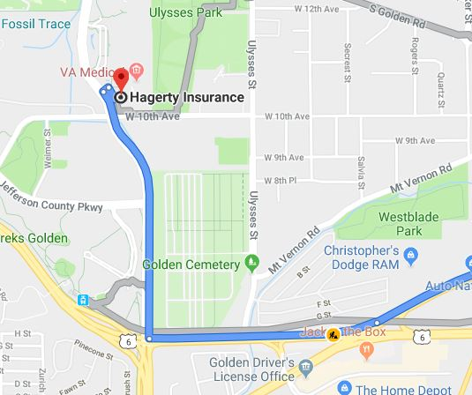  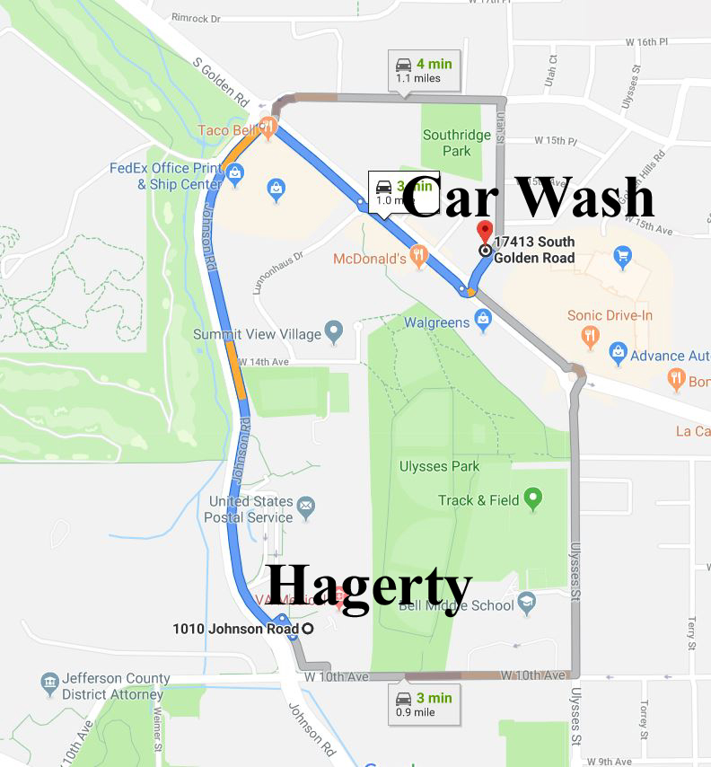  Car Wash located at  17413 S. Golden Rd. | 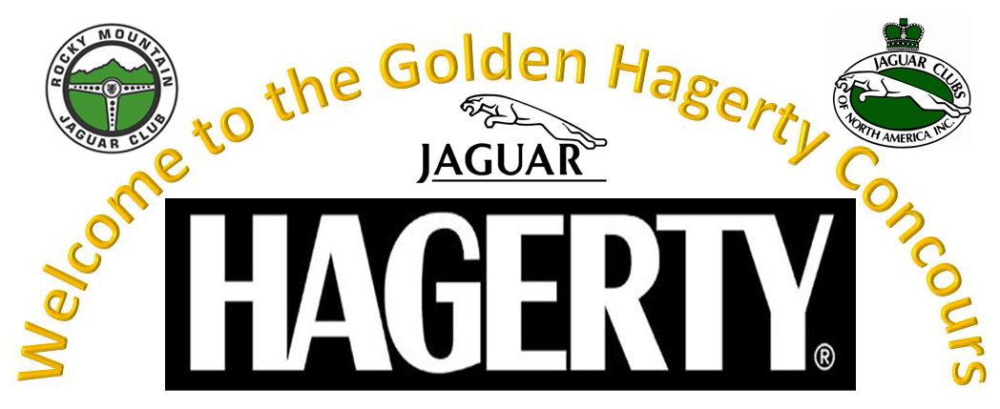  2019 RMJC Concours d’Elegance  Sunday, June 23, 2019  1010 Johnson Road  Golden, CO 80401  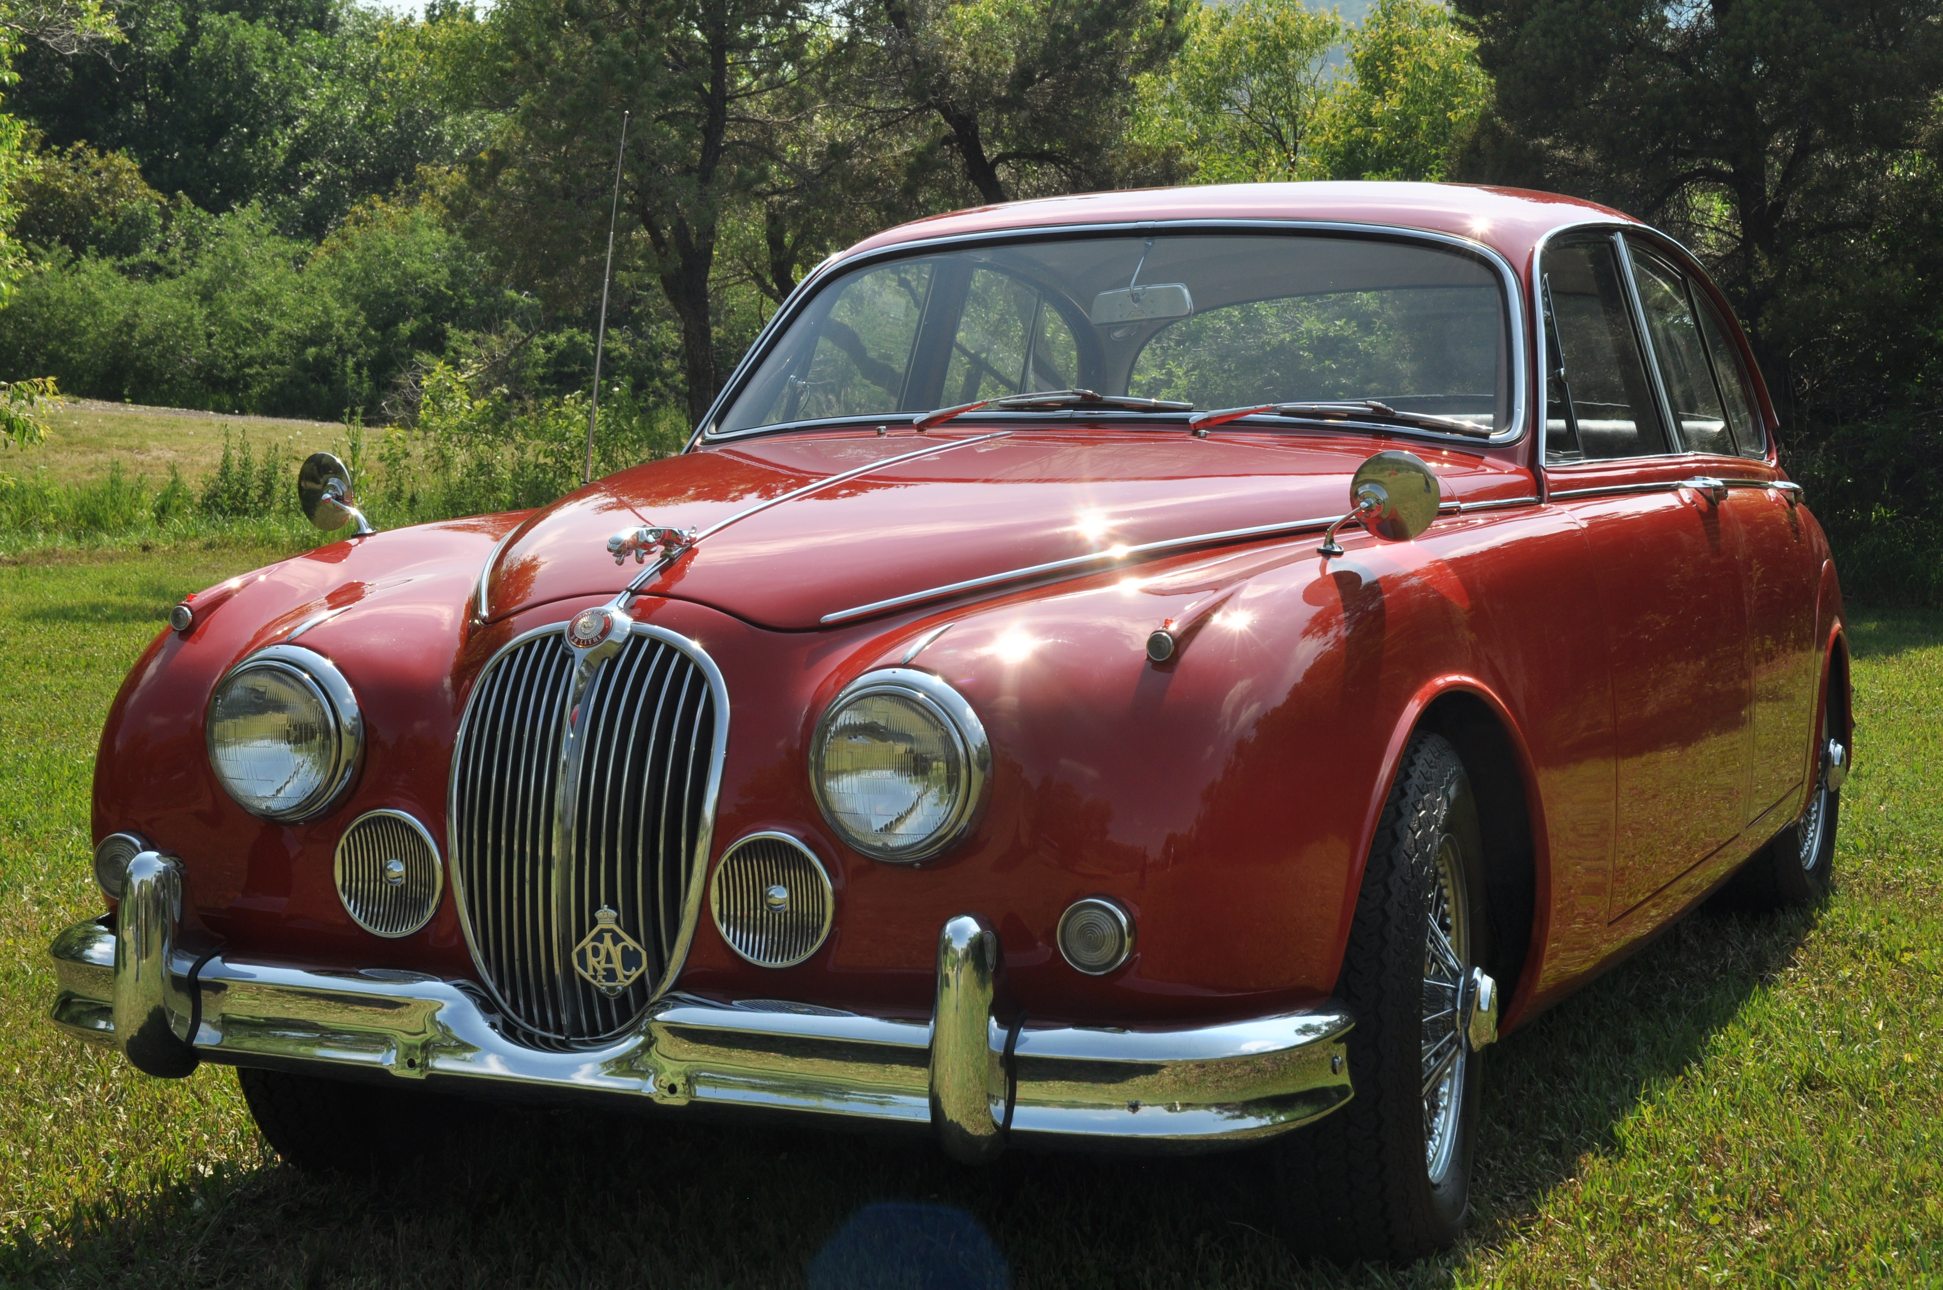  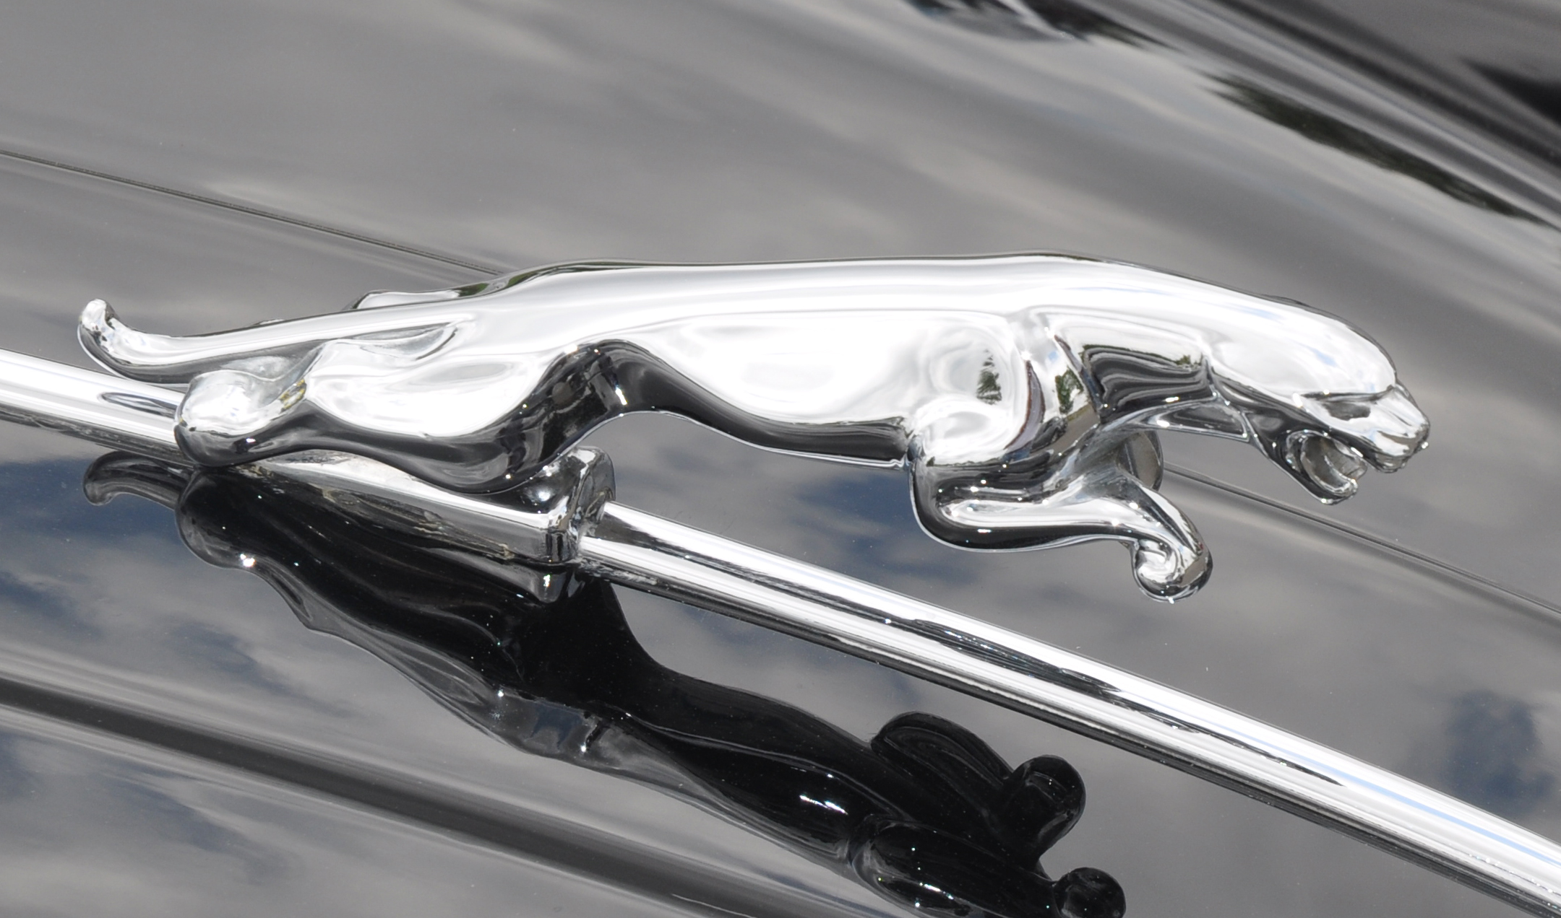  Contact Information:  Deanie Kennedy, dkennedy@ecentral.com, 303-489-3944  Steve Kennedy, skennedy@ecentral.com,  303-489-3955
2019 Rocky Mountain Jaguar Club  Concours d’Elegance  Golden, CO  Sunday, June 23rd  1010 Johnson Road  Golden, CO 80401  Schedule:  Open at 8:00 am  Coffee & Donuts/Breakfast 8:30-9:30  Rags Down at 10:00  Judging 10:30-1:30  Lunch 11:30-1:00  Cocktails: 5:00  Awards Dinner: 6:00  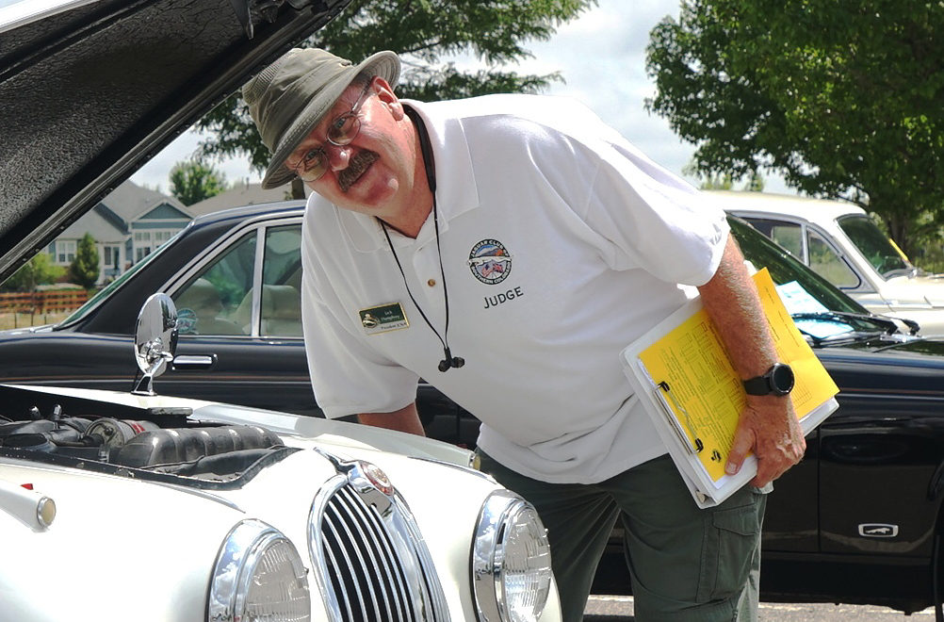  Judging at 10:30  Hotel Information  Holiday Inn Express (.9 mi)  17140 W Colfax Ave, Golden, CO, 80401, 866-925-7881, ~ $125.00  Hampton Inn-Denver West (.9 mi)  17150 W Colfax Ave, Golden, CO, 80401, 866-925-7881, ~ $135.00 | CHAMPION DIVISION CLASSES  C1/PRE: Classics (Pre-XK engine) Tourer, OTS, DHC and Saloons: Swallow, SS & SS Jaguar (1927-51)  C2/120: XK 120 (1948-54)  C3/140: XK 140 (1955-57)  C4/150: XK 150 (1957-61)  C5/E1: E-Types, Series 1 (1961-67)  C6/E2: E-Types, Series 1.5 (1968) and Series 2  E-Types (1968-71)  C7/E3: E-Types, Series 3 (1971-75)  C8/SLS: Early Large Saloons: MK VII, MK VIII, MK IX, MK 10, 420G, (1950-70); Early Small Saloons: MK 1 (2.4 & 3.4), MK 2 Series (2.4, 3.4, 3.8 liter, Daimler V8), 240, 340; S-Type 3.4S, 3.8S, & Jaguar and Daimler 420 (1955-69)  C9/XJ: XJ6/12 Series 1 Saloons (1968-73); XJ6/12 Series 2 Saloons and Coupes (1973-79); Series III XJ6, XJ6 Sovereign and XJ6 VDP (1979-87); Series III V12 and V12 VDP (1979-92)  C10/XJ: XJ6 (XJ40) Sedans (1987-94), XJ12 (XJ40) (1993-94); XJ6/12/R, (X300) (1995-97)  C11/J8: XJ8/R Sedans (X308) (1998-2003), XJ8/R Sedans (X350 Alloy) (2004-2009)  C12/JS: XJ-S/SC (1976 - 1991 Pre-Facelift) Coupe, Cabriolet, H&E Convertible, Convertible,  XJR-S Le Mans, XJR-S Jaguar Sport.  C13/JS: XJS (1991 - 1996 Facelift) Coupe, Convertible, XJR-S Jaguar Sport.  C14/K8: XK8 Coupe and Conv. (1996-2006), XKR (1999-2006)  C15/XK: XK and XKR Coupe and Conv. (2007-On)  C16/SX: S-TYPE Sedans (1999-2008), X-TYPE Sedans and Estate Wagon (2002-2008)  C17/PN: Preservation Class (more than 35 years old)  C18/PN: Preservation Class (20 to 35 years old)  C19/FJ: XF Sedans (2008-On), XJ Sedan (2010 [as 2011 model year] – On), XE (2016 Model Year)  C20/F: F-TYPE (2013-On)  C21/FP: F-PACE, E-PACE, I-PACE  SPECIAL DIVISION CLASSES  S1/PD: Factory-produced and prepared Competition Jaguars, Factory-sponsored Competition and Limited Production Jaguars and Production Jaguars privately prepared and modified for competition  S2/MOD: Modified  S3/REP: Replica (non-production, Jaguar powered) | DRIVEN DIVISION, CLASSES  D1/PRE: All Classics (Pre-XK engine) and XK 120, XK 140, XK 150  D2/E1: E-Types (1961-67)  D3/E2: E-Types Series 1.5 (1968) and Series 2 E-Types (1968-71)  D4/E3: Series 3 E-Types (1971-75)  D5/SLS: Early Large Saloons: MK VII, MK VIII, MK IX, MK 10, 420G, (1950-70); Early Small Saloons: MK 1 (2.4 & 3.4), MK 2 Series (2.4, 3.4, 3.8 liter, Daimler V8), 240, 340; S-Type 3.4S, 3.8S, & Jaguar and Daimler 420 (1955-69)  D6/XJ: XJ6/12 Series 1 & 2, Saloons and Coupes (1968-79); Series III XJ6, XJ6 Sovereign and XJ6 VDP (1979-87); Series III V12 and V12 VDP (1979-92)  D7/XJ: XJ6 (XJ40) Sedans (1987-94); XJ12 (XJ40) (1993-94); XJ6/12/R, (X300) (1995-97)  D8/XJS: XJ-S/SC (1976 - 1991 Pre-Facelift) Coupe, Cabriolet, H&E Convertible, Convertible,  XJR-S Le Mans, XJR-S Jaguar Sport.  D9/XJS: XJS (1991 - 1996 Facelift) Coupe, Convertible, XJR-S Jaguar Sport.  D10/K8: XK8 Coupe and Conv. (1996-2006), XKR (1999-2006)  D11/XK: New XK and XKR Coupe and Conv. (2007-On)  D12/J8: XJ8/R Sedans (X308) (1998-2003), XJ8/R Sedans (X350 Alloy) (2004- 2009)  D13/SX: S-TYPE Sedans (1999-2008), X-TYPE Sedans and Estate Wagons (2002-2008)  D14/FJ: XF Sedans (2008-On), XJ Sedan (2010 [as 2011 model year] – On), XE (2016 Model Year)  D15/F: F-TYPE (2013-On)  D16/FP: F-PACE, E-PACE, I-PACE)  Make checks Payable to: RMJC  Mail To: RMJC Treasurer  Deanie Kennedy  8137 Zang St.  Arvada, CO 80005  Or register on line at: http://www.rockymountainjaguarclub.org/  

